Photo to use:
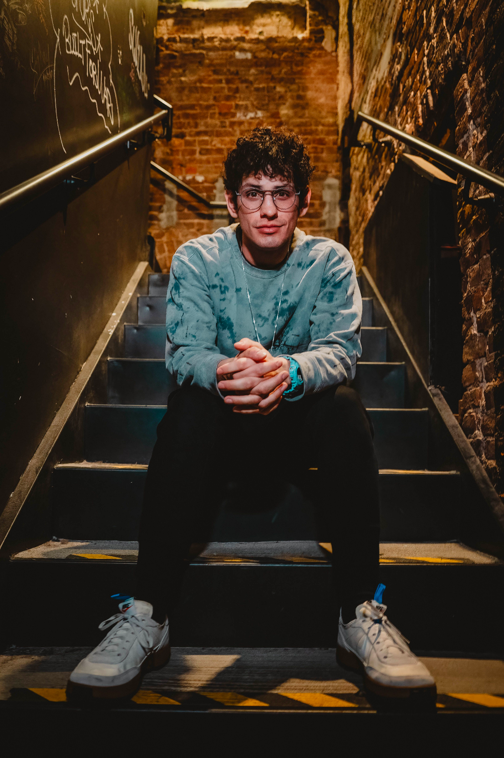

Bio:
Party101 is a throwback DJ night that came to life in 2022 through the mind of Nickelodeon star Matt Bennett. Matt has taken these shows to ~100 cities, gaining the attraction of thousands of concert-goers from the United States, the UK, and across Europe. Joining him onstage has been a number of special celebrity guests including Elizabeth Gillies, Daniella Monet, Avan Jogia, and Stephen Kramer Glickman. These shows feature a massive dance party with music from both Disney and Nickelodeon and continue to sell out across North America!
Stats:
2012 Kids’ Choice Awards “Favorite TV Show” Winner
2013 Kids’ Choice Awards “Favorite TV Show” Winner
2011 UK Kids’ Choice Awards “Nick’s Funniest Person” Nominee
2012-2013 Panelist role in Figure It Out
2023 U.S DJ Tour with “Party101”
Victorious Season 1 Pilot: 5.7m views
Victorious Season 1 Episode 2: 3.48m views
Victorious Season 2 Episode 1: 6.1m views
iParty (2022) # of Shows: 42
Party 101 Shows in 2023: 82

Socials:

IG: 1.7m
Party101 IG: 23.9k
TT: 624.1k
Party101 TT: 47k

Logo:
